

**ALAGAPPA COLLEGE OF TECHNOLOGY**

**ANNA UNIVERSITY-600025**

**NM Assignment / Digital Marketing**

|  |  |  |
| --- | --- | --- |
| NAME | REG.NO | Naan Mudhalvan ID |
| KAVIYA P | 2020308019 | A8513A0289BE36897F64655932B14543 |

1. **Create a blog or website using Blogpost Customize the theme design and post new article with 500 words.**

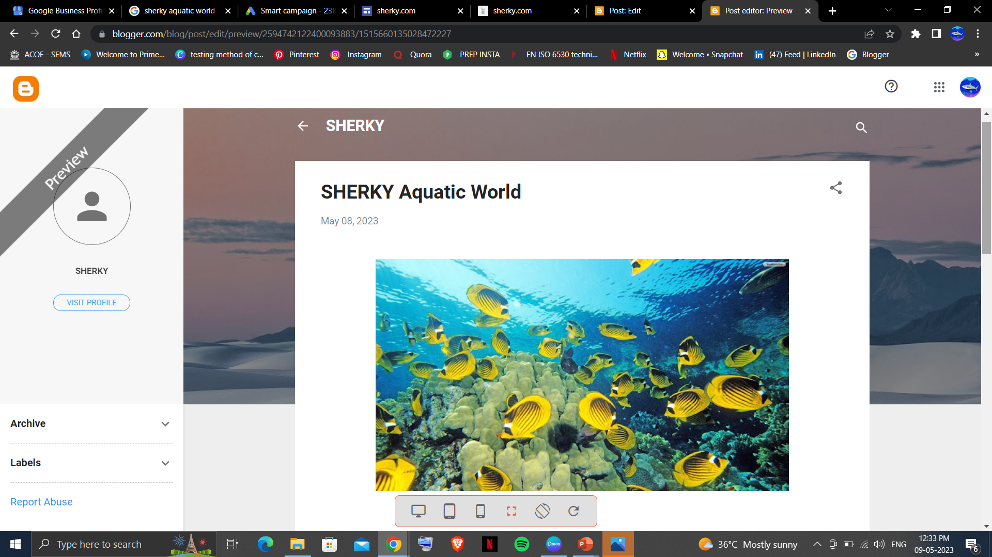

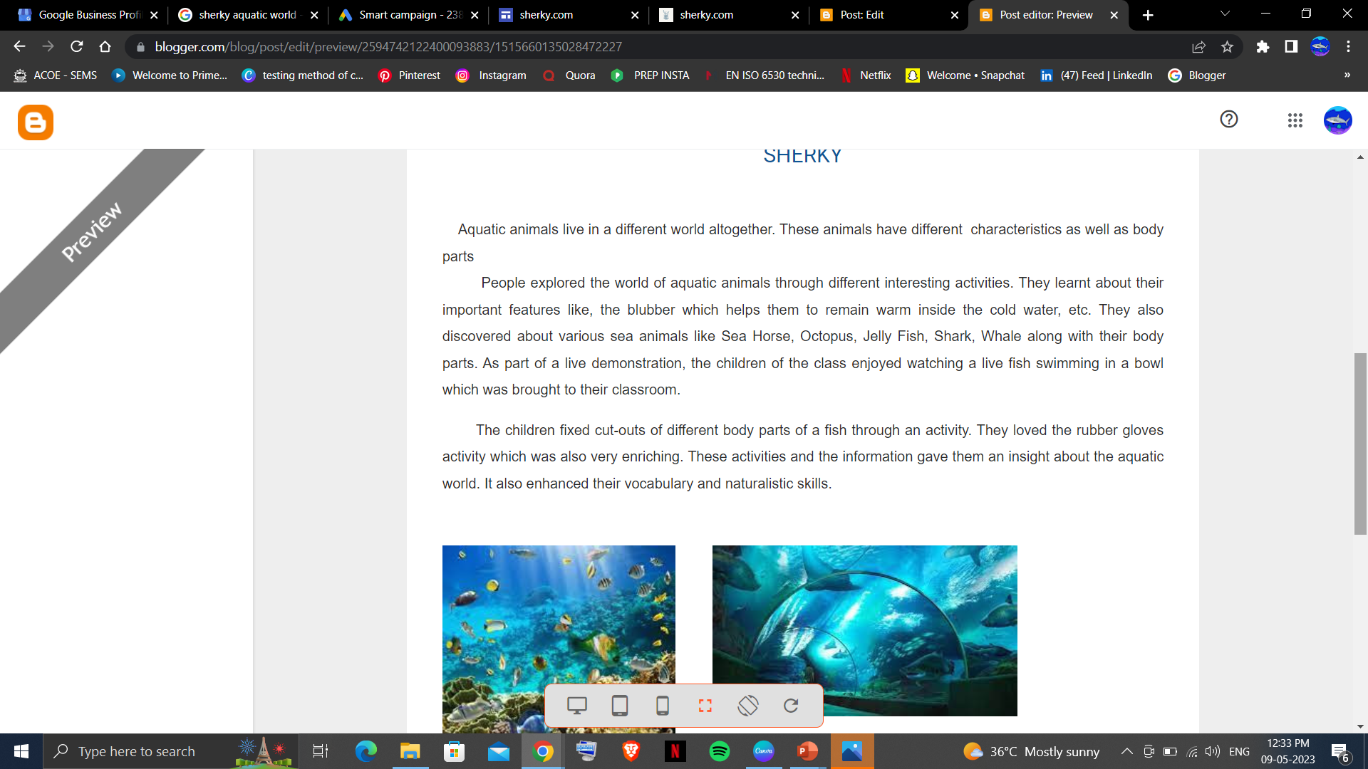

1. Create a New Facebook Business Page and post one social media poster for your brand.

https://m.facebook.com/story.php?story_fbid=pfbid02jgGnuRvAh5CycaXVbZf63FG9vpHy9JmqenARTf3RdSPTGgbwkC49s9D8zUwcz6Jdl&id=61552766166697&mibextid=Nif5oz

3. Create and design a social media advertisement poster using canva.

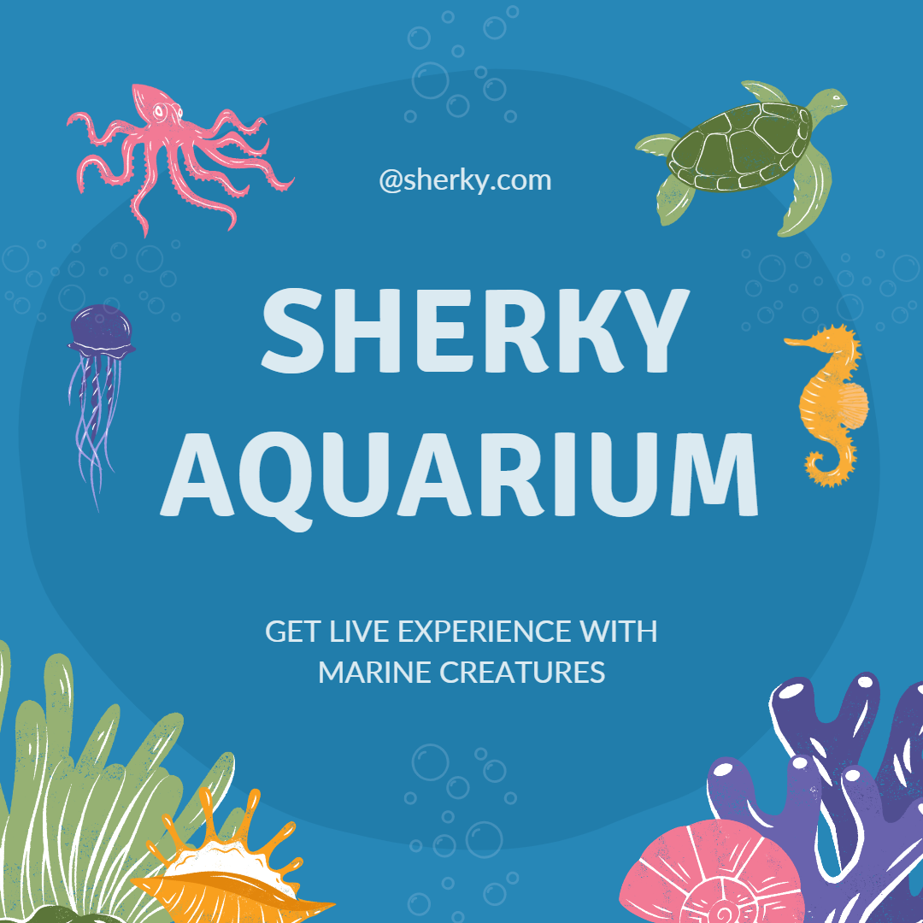

4. Create email newsletter design using MailChimp or canva tool.

